Event Registration System

Name : Sandeep D S

MID: M1027715

Project Description:

Design and implement an “Event registration” system for company. It will be used by event management admin to register an employee with an event, so that employees can get notifications regarding their favorite events. An employee may be interested in zero or more events. Also, an event may have multiple subscribers (interested employees).

Requirement:

Develop Menu driven application to implement following feature.

* Register employee for events
* Display all employees

Screen Shot of Output:

Display of Menu



Case 1 : Employee registration for Events

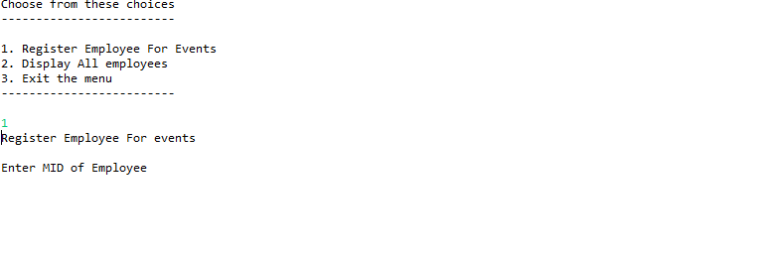

Entered MID of Employee, Showed the list of events so the employee wishes to enroll..

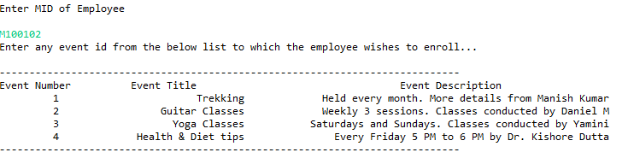

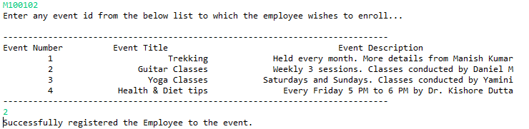

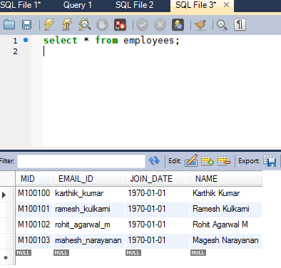

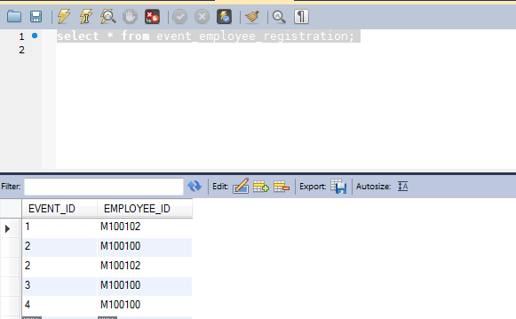

Case 2: When employee doesn’t exist in database



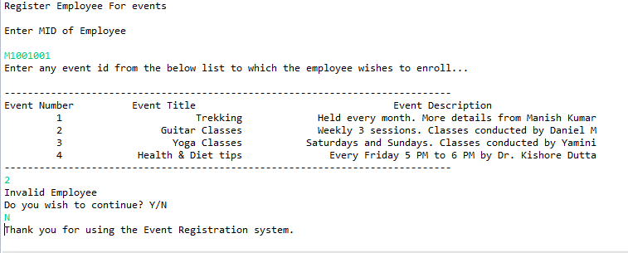

Case 3 : When event doesn’t exist in the database



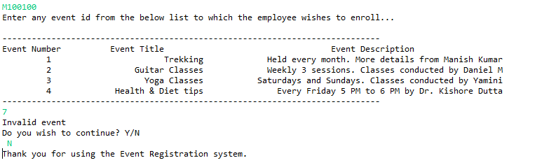

Case 4: When employee is already registered to the event – Display registration failure



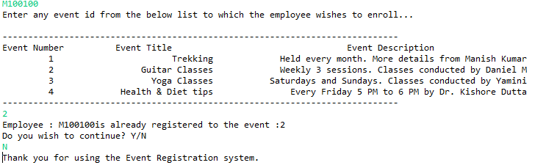

Case 5: List of all the employees in the system

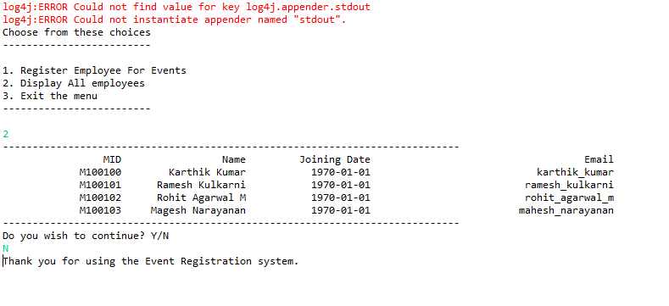

Database Employee Data

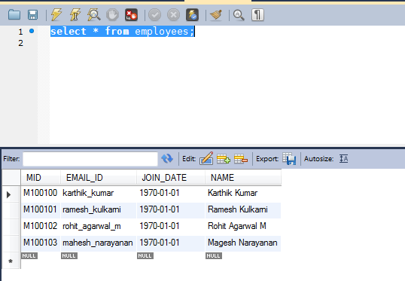

Database Events Details

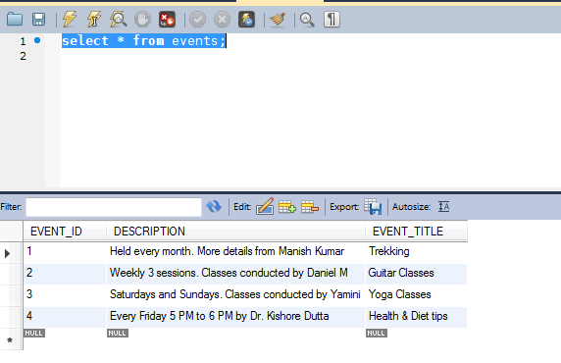

Project Tools:

* IDE : Eclipse Mars
* Database: MYSQL 5.5
* Hibernate: 5.2